**Answer to question no: 01**

Acceptance Criteria for Feature 1:

**1**. A 1% service charge will be deducted from the customer's balance;

**2**. Minimum service charge must be 5tk, even if 1% of the transaction amount is less than

5 taka;

**3.** If a customer makes a transaction of more than 5000tk, they will get 10% cashback;

**4.** If a customer makes a transaction of more than 10,000tk, they will get 20% cashback;

**5.** The max cashback is limited to 3000tk, even if 20% of the transaction amount is higher;

**6.** No cashback will be applied to utility bills.

**7**. For any change or information, the user should be informed by sms.

Acceptance Criteria for Feature 2:

1. A customer can apply for a loan up to 20000 tk only if their balance is less than 100tk;

2. If the customer repays the loan within 30 days from the loan initiation day, no interest

will be charged

3. If the customer fails to repay within this period, a daily interest of 1.8% will be

applied in a compound interest manner on the remaining amount;

4. If a customer has already paid 50% of the remaining payment, they are eligible to

apply for another loan.

5. The customer should be notified about the 30-day repayment period, balance, etc.

information.

**Answer to question no: 04**

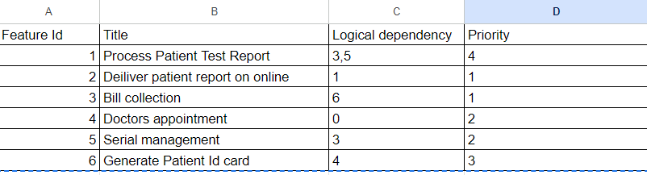

Priority sequence : 4 > 6 > 3 > 5 > 1 > 2

**Explanation:**

**i)** As for feature id 4, logical dependency is 0 so it will be the first priority;

**ii)** 4 is the logical dependency of feature id 6. For that it will be second;

**iii)** As 6 is the logical dependency of 3; so it comes in third;

**iv)** 3 is the logical dependency for both feature id 1 and 5; 5 is the logical dependency of feature id 1 as well. So, to satisfy feature id 1, first have to go through 3 and then 5.

Finally, after feature id 3 and feature id 5, feature id 1 will be on the list.

**v)** lastly, feature id 2 will be in sequence as its’ logical dependency is 1.